JOSE CERDA MEMORIAL SWIM CLINIC PROGRAM
October 28, 2018

This Clinic is in memory of the swimmer José Cerdá. José sadly missed his sectional time cut in 100 m back stroke by 0.01 seconds. Rather than being disappointed by it, José became more dedicated to the sport to shave that one hundredth of a second from his time to qualify for the event and achieve his goals. We would like this Clinic to inspire your “point zero one” moment, because the smallest difference can have a BIG impact

EIGHTH ANNUAL JOSE CERDA MEMORIAL SWIM CLINIC
October 28, 2018
Mason Community Center
6050 Mason Montgomery Rd. Mason, OH 45040

CHAMPION ATHLETES SHORT BIOGRAPHIES

ZANE GROTHE  2018 PAN PACIFIC GOLD MEDALIST | MARGO GEER  2018 PAN PACIFIC SILVER MEDALIST
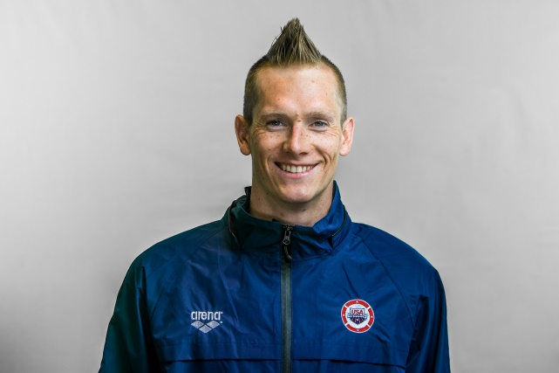 | 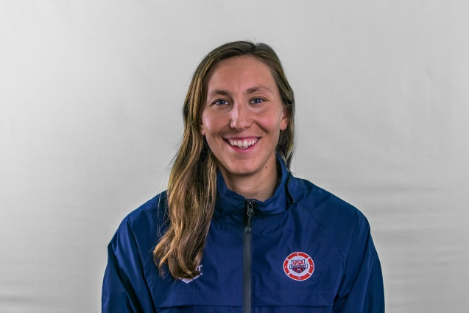
Hometown: Boulder City, Nevada.  Birth date: April 22, 1992. College: Auburn University ‘14  Zane had his first swimming lesson at 6 weeks old to learn water safety. He attended Boulder City High School and graduated in Aerospace Engineering from Auburn University in 2014.  Zane swims 13,000 yards/meters a day ... 4 hours a day ... 2 workouts a day, 6 days a week.  Zane won gold in the 800 freestyle; silver in the 1500 and bronze in the 400 at the Pan Pacific Championships held in Tokyo, Japan in August 2018. He was the champion in the 400m and 800m free at 2018 Phillips 66 Nationals and set the American records in the 500y and 1650y free at the 2017 Winter National Championships. While at Auburn University, Grothe cemented his name as one of the schools best distance freestylers, holding records in the 500, 1,000, and 1,650 yard freestyle along with the 800 yard freestyle relay by the time his senior season concluded. Over his four-year campaign he collected 12 All-American honors and was a two-time SEC champion. | Hometown: Milford Center, Ohio.  Birth date: March 17, 1992.College: University of Arizona ‘14  Inspired by her older brother, Geer started swimming when she was four years old. Growing up, she swam for the Springfield YMCA and Fairbanks High School. Geer completed her collegiate career at Arizona as a 23-time All-American, three-time NCAA Champion, and school record holder in the 100-yard freestyle (47.14), 800-yard freestyle relay, and 400-yard freestyle relay. In 2008, Geer qualified to compete at her first U.S. Olympic Trials, where she finished 41st in the 50-meter freestyle with a time of 26.15. Geer qualified for her second Olympic Trials in the 50-meter freestyle and the 100-meter freestyle. She finished 7th in the 50 with a 25.26 and 12th in the 100 with a 54.85. At the 2018 U.S. National Championships, Geer earned a bronze medal in the 50 freestyle (24.79) and 100 freestyle (53.44). At the 2018 Pan Pacific Championships, Geer swam prelims of the 100 free, and ultimately wound up 3rd in the B-final (54.47) at night. On day 3, she went 2nd on the 4×100 free relay in a time of 53.59 to help the USA women secure a silver in the event.

DAVID MOSKO | ALEX NORRIS
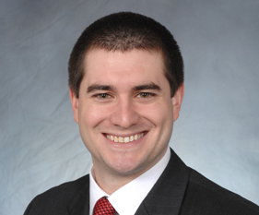 | 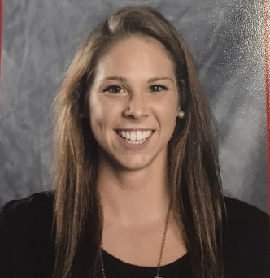
David was born in Cincinnati, started his swimming career at the age of 6 and swam for the Cincinnati Marlins Club. He attended St. X High School and graduated from Stanford University with a B. Sc. in Biomechanical Engineering in 2012, where he made multiple appearances in NCAA finals and was a 14-time NCAA All-American. He was a World University Games finalist in 2011 and semi-finalist at the Olympic Trials in 2008 and 2012. He holds the Ohio high school state record in the 500 freestyle and he is an eight- time State Champion (4 individual, 4 relays). David has been a Coach with the Cincinnati Marlins, graduated from medical school at UC and is doing his residency at Christ Hospital. | Alex was born in Cincinnati, and started swimming competitively at the age of 8. She went to Sycamore High School and swam for the Cincinnati Marlins during her high school years. She graduated from the Ohio State University in 2014 with a Bachelor in Exercise Physiology with Honors Research Distinction. During her collegiate swimming career, she specialized in the middle-distance and distance freestyles as well as the IM events, and was a 4x-NCAA qualifier, multiple-event team record holder, 2x All-American honorable mention, 2x Big Ten runner-up, 2012 and 2016 US Olympic Trials Qualifier, Big Ten Medal of Honor Finalist, and award winner of the Big Ten Postgraduate Scholarship and Leann Grimes-Davidge Scholarship. She continued her education at Ohio State in their Doctoral Physical Therapy program while continuing to swim and train with the university as a post-graduate student. She qualified and competed at the 2016 US Olympic Trials in the 200/400/800 freestyles and 200 IM. Alex graduated in 2017 with a Doctorate in Physical Therapy. She now resides in Columbus, Ohio and works as an outpatient sports and orthopedic physical therapist at Orthopedic One.
KERRY TEPE
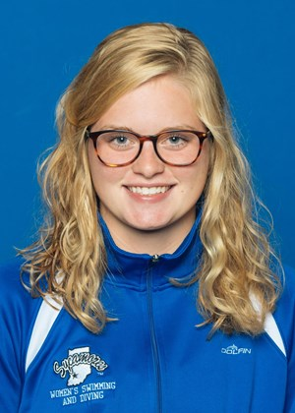
Kerry was born in Cincinnati, and started swimming competitively at the age of 8. She attended to Colerain High School and swam for the Powel Crosley Jr. YMCA Tigersharks. She was a member of the National Team from 2012-2017 as well as a three time Ohio State qualifier in the 100 breaststroke. She is currently continuing her swimming career collegiately at Indiana State University where she is majoring in Biology with a minor in Psychology.

JCAF PARTNERS
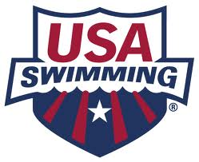 | 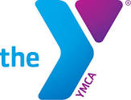

EIGHTH ANNUAL JOSE CERDA SWIM CLINIC SCHEDULE

MASON COMMUNITY CENTER- Sunday, October 28th 2018
10/28/2018 | Activity
Time | Classroom | Water
8:30-8:50 am | Registration - swimmers up to 12 years old (water), 13 & older (talks)
9:00-10:00 am | None | Water Instruction – swimmers up to 12 years old only. Drills based on ability level: Developmental swimming vs. Club experience. Younger group 6-8 yrs. old can do 1 hour only as appropriate.
10:00-11:00 am | Nutrition Talk for Swimmers (13 years & older) & Parents  Dawn Weatherwax, RD, CSSD, LD, ATC, CSCS (sn2g.com)
11:00 am -11:40pm | Lunch Break
11:20 am - 11:40am | Registration for swimmers 13 years and older (water)
11:40-12:30 pm | (W)In the Moment (all swimmers & parents). Putting in all the work, spending all the dollars and the time, then coming to that BIG meet. Now what? All the work can come to nothing if the space between an athletes ears isn’t on track to (W)In the Moment. You have to be IN the Moment in order to (W)In the Moment. Learn some practical parts to your peak performance - for athletes and the parents who support them.  Jeff Raker, Level Up Leadership Coaching, Sherpa Certified Coach has been involved with the world of swimming for the past 49 years: as an athlete, coach, parent of swimmers, and now FINA Starter and Master’s athlete.
12:30- 12:40 pm | CHARACTER  Meredith Griffin  Assistant Director of Competitive Aquatics  YMCA OF GREATER CINCINNATI  Powel Crosley, Jr. YMCA
12:40 pm-1:00pm | Q&A, Autographs, & Photos with Champions  (All swimmers, parents, & coaches)
1:00-2:00pm | Study of strokes, starts and turns- Session  for all swimmers  Jason Roberts (Head Coach Countryside YMCA) |  | None
2:00-3:00pm | College Swimming and Recruiting Q&A Session for Parents  MANDY COMMONS DISALLE- UNIVERSITY OF CINCINNATI (DI) HEAD SWIMMING COACH  BILL DORENKOTT- OHIO STATE (DI) HEAD SWIMMING COACH  BRENT MACDONALD- XAVIER UNIVERSITY (DI) HEAD SWIMMING COACH  JONAS PERSSON, OLY- UNIVERSITY OF TOLEDO (DI)HEAD SWIMMING & DIVING COACH  RON ALLEN- ASHLAND UNIVERSITY (DII) SWIMMING HEAD COACH  STEPHANIE GYURKE- NOTRE DAME (DII) COLLEGE HEAD SWIMMING COACH  LAURA (WOLFF) DEMALINE- HEAD COACH BALDWIN WALLACE UNIVERSITY (DIII) |  | Water Instruction - swimmers 13 years and older
3:00-4:00pm | Prevention of Swimming-related injuries  Elizabeth Long PT, DPT, OCS  Sports Medicine/ Orthopedic Physical Therapist  Cincinnati Children's Hospital Medical Center Liberty Campus

JCAF WOULD LIKE TO THANK ALL WHO MADE THIS SWIM CLINIC POSSIBLE
Dan Chambers | Rob Johnson | Val Lyons | UC Swim Team
Chrissy Avery | Ryan Hammer | Nicolas Messer | Keegan Veraldo
Wendy Bartlett | Beverly Kirk | Claudia Multer | Bill Whatley
Phil Dubois | Mike Leonard | Erin Schwab | Carol Wolkoff
Zerlina Dubois | Mac Lewis | Terry Sojda | Colleen Wunderle
 |  | Tina Sojda | Dean Wunderle

RON ALLEN- ASHLAND UNIVERSITY SWIMMING HEAD COACH (DII)
TODD BILLHIMER- HEAD AGE GROUP COACH MASON MANTA RAYS
MANDY COMMONS DI SALLE- UC HEAD SWIMMING COACH (DI)
BILL DORENKOTT- OSU DIRECTOR OF SWIMMING AND DIVING (DI)
MEREDITH GRIFFIN- ASST. DIR. COMPETITIVE AQUATICS YMCA GR. CINCINNATI
STEPHANIE GYURKE- NOTRE DAME COLLEGE HEAD SWIMMING COACH
BRENT MACDONALD- XAVIER UNIVERSITY HEAD SWIMMING COACH (DI)
JONAS PERSSON- UNIVERSITY OF TOLEDO HEAD SWIMMING COACH
JEFF RAKER- Level Up Leadership Coaching, Sherpa Certified Coach
JASON ROBERTS- COUNTRYSIDE YMCA HEAD COACH
DAWN WEATHERWAX – SPORTS NUTRITION 2 GO
LAURA (WOLFF) DEMALINE- HEAD COACH BALDWIN WALLACE UNIVERSITY

SPONSORS
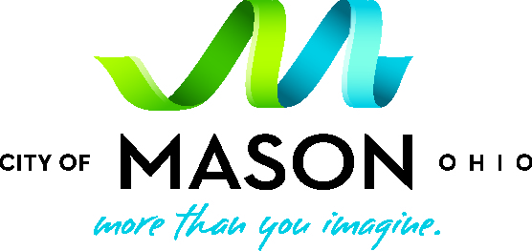 | 