Dear Parents,

I wanted to make you aware of an excellent opportunity that’s been made available to our athletes at Sycamore High School. We are partnering with mCORE™ — Mobile Cardiac Overview and Risk Evaluation — to screen our athletes for the cardiac conditions and abnormalities which may put them at risk of Sudden Cardiac Arrest (SCA). mCORE partners with high schools and athletic organizations to give convenient and dependable heart screenings to students. SCA is the #1 Killer of Student Athletes Each Year, many of which could have been prevented with a simple examination like this. Space is limited, so Sign up Today at www.mcoreathletes.com or for more information on mCORE and SCA please see video link below
https://vimeo.com/53605191/
This Screening Is In Honor Of Jose Cerda, An Aviator Who Lost His Life to Sudden Cardiac Arrest in 2010.
- Date: Wednesday February 10, 2016
- Time: 8:00am - 4:00 pm
- Location: Sports Medicine Office

The time requirement is approximately 10-12 minutes per athlete. Each athlete will be given an EKG and Echo screening and these tests typically cost more than $2000 in a clinical setting. The cost to you is $75. The screening age range is (14-22 years). You may use your Healthcare Spending Account or Flex Care Spending Account. All screenings are performed by a Registered Diagnostic Cardiac Sonographer and results are read by the mCORE Medical Director Dr. Kenneth Berkovitz, MD. Board Certified in Cardiovascular Disease, Interventional Cardiology and Internal Medicine (Please contact mCORE should financial hardship preclude you from taking part)

ATHLETES MUST PRE-REGISTER ONLINE FOR THE SCREENING BY VISITING: www.mCOREathletes.com or for questions call Chad Ogden at 614-648-4656 or Liz Belcher at 614-216-9157

“In the United States, One Young Competitive Athlete Dies Every Three Days From Unrecognized Cardiovascular Disorder.” The American Heart Association
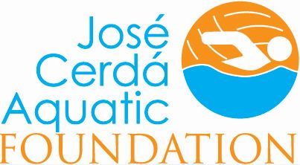 http://www.jcafoundation.org/ http://joseito.org

